

MATHEMATICS
Specialist Units 3 & 4

Test 4 – Antidifferentiation and Definite Integrals

Semester 2 2019

Section Two – Calculator Assumed

Time allowed for this section
Working time for this section: 31 minutes
Marks available: 31 marks

Material required/recommended for this section

To be provided by the supervisor
This Question/Answer booklet
Formula sheet

To be provided by the candidate
Standard items: pens, pencils, pencil sharpener, eraser, correction fluid, ruler, highlighters

Special items: drawing instruments, templates, notes on one unfolded sheet of A4 paper, and up to three calculators satisfying the conditions set by the Curriculum Council for this course.

Important note to candidates
No other items may be used in this section of the examination. It is your responsibility to ensure that you do not have any unauthorised notes or other items of a non-personal nature in the examination room. If you have any unauthorised material with you, hand it to the supervisor before reading any further.
- (8 marks: 3, 5)
The graph of the curve of equation $\sqrt{x}+2\sqrt{y}=6$ is shown below. The line of equation $x+2y=12$ is tangent to the curve at point P. The shaded region is enclosed by the curve, the tangent line and the $x$ axis.
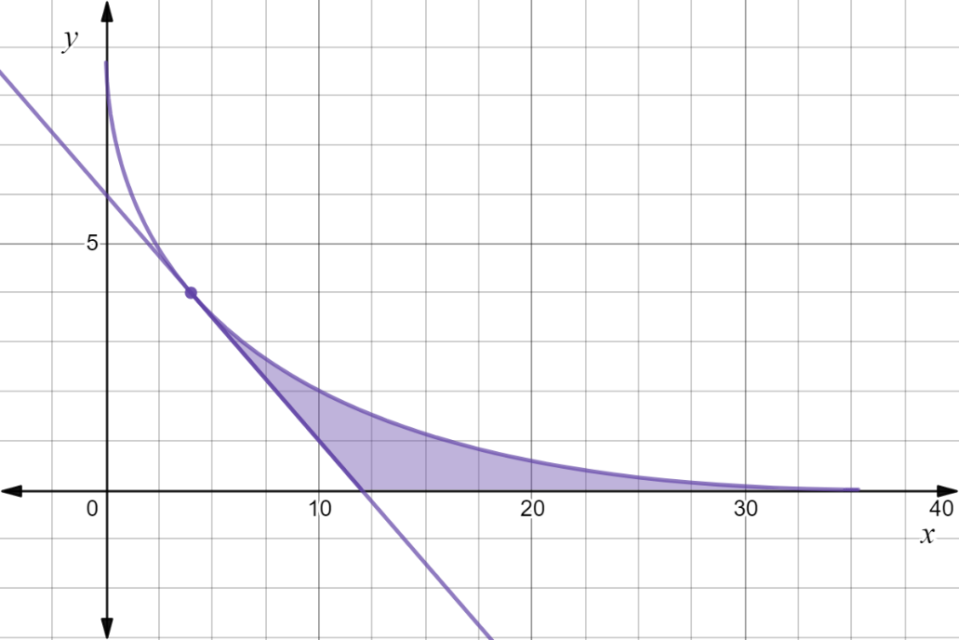

P

- Find the co-ordinates of point P and the $x$ intercepts of the curve and the tangent line.

- Find an integral expression for the area of this region in terms of
- horizontal elementary slices (i.e. with respect to y)

- vertical elementary slices (i.e. with respect to x)

- (8 marks: 4, 4)
For the curves with equations $2y^{2} -9x=0$ and $y^{2} -12x+60=0$ determine the volume of the solid formed when the region enclosed by the two curves is
- rotated about the $y axis.$

- rotated about the $x$ axis

- (5 marks)
A bucket has a circular base of radius $r$ cm and a circular rim of radius $R$ cm. The perpendicular height of the bucket is $H$ cm. Use calculus techniques to determine, in simplest form, the volume of water, in terms of $r, R and H,$ this bucket will hold when full.

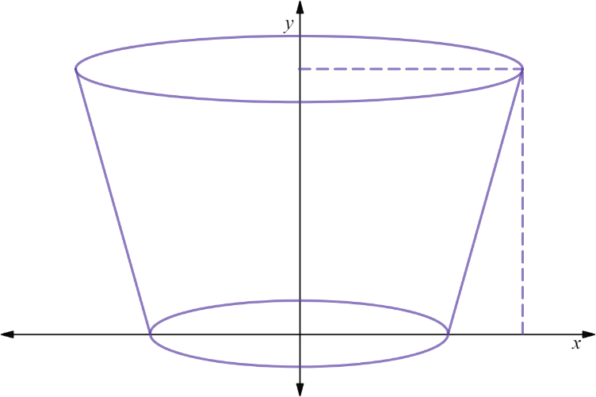
$$(R, H)$$

$$(r, 0)$$

- (5 marks)
Below is shown the uniform cross-section of a drainage canal (shaded), the bed of which is described by curves; $4y+$ $e^{5xln2}$ $=2$ and $4x+y = 2.5x^{2}$, where $x$ and $y$ are measured in metres and the $x$ axis represents the water level. If the water is flowing at the rate of $3.5 m/s$ then how many kilolitres (to the nearest kL) of water will pass by in two minutes.
Note: 1 m³ = 1kL
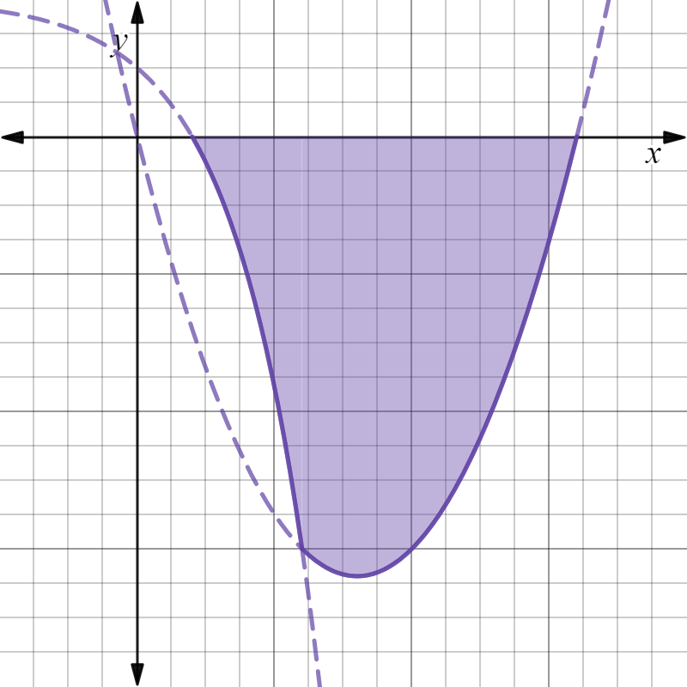

- (5 marks: 3, 2)
The ellipse shown has equation $\frac{x^{2}}{a^{2}}+\frac{y^{2}}{b^{2}}$ $=1$ with $a>b>0$ .
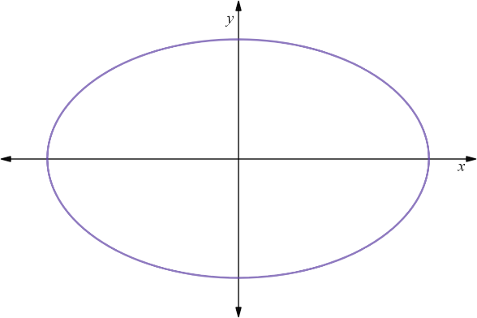

Use a suitable integral to determine, in terms of $a and b$,

- the area of the ellipse.

- the volume of the ellipsoid formed by rotation of the ellipse about the $x$ axis.

End of Test
This page has intentionally been left blank
You may use this space to extend or re-attempt an answer to a question or questions and should you do so then number the question(s) attempted and cross out any previous unwanted working.

This page has intentionally been left blank
You may use this space to extend or re-attempt an answer to a question or questions and should you do so then number the question(s) attempted and cross out any previous unwanted working.

